
Activity Report & Photographs
March 2024 – March 2025

Month | Activity | Run by | Notes
March 2024 | Monthly meet-up with guest speakers from Healthwatch | RCF  Healthwatch  Management team | Service invited to give carers an insight into the work they do. There was an opportunity to ask questions and further leaflet guidance was made available. The information was later shared to all members via email.
April | Absolute Advocacy | Steve Mace  RCF | Service invited to give experience of advocacy work in our borough. Rotherham Deaf community group invited and interpreter booked and attended. There was an opportunity to ask questions and further leaflet guidance was made available. The information was later shared to all members via email.
May | Monthly meet-up – with Mayor visit | RCF | The Mayor was invited to attend the session. He spoke with all members and listened to their experiences and fed this back to the council.
June | Carers week | Jayne Price  Vickie Hobson  RCF | Several events held including monthly meet.  Pictures below.  All information shared with members signed to mailing list via email and community social media pages.
July | Monthly meet up | RCF | Chat, cuppa & Food
August | NO MEET-UP | BREAK FOR HOLIDAYS
Sept | Rotherham show & monthly meet-up | Jayne  Vickie  RCF | Monthly meet up and held an awareness stall at the Rotherham Show – pictures below
Oct | World Mental Health awareness  Monthly Meet-up | Vickie Hobson  RCF | Interactive wellbeing session lead by Vickie and capturing the emotional health of carers.
Nov | Carers Rights week  Monthly meet-up | Jayne  Vickie  RCF | Raising awareness of carers rights by holding a stall at Rotherham Hospital  Engagement event  Monthly meet-up  Pictures below
Dec | Monthly Meet-up | Vickie  Jayne  RCF | Christmas disco, quiz, bingo.
Jan 2025 | Monthly Meet-up with guest service the Money Charity | Money Charity  Jayne Price  RCF | Monthly meet-up with a presentation from the charity covering, financial management, financial wellbeing, financial scams, power of attorney. There was an opportunity to ask questions and further leaflet guidance was made available. The information was later shared to all members via email.
Feb | Monthly meet-up with guest speaker from RDaSH | RDaSH  RCF | Guest speaker from the service invited to discuss the service, what help is available and what they can do for carers. There was an opportunity to ask questions and further leaflet guidance was made available. The information was later shared to all members via email.
March | RCF Annual General Meeting | RCF  Jayne Price  Vickie Hobson | An open AGM was held and attended by over 30 people including all the management team, forum members, local councillors, local services and representatives from the RMBC.

Abbreviations: RCF – Rotherham Carers Forum
RDaSH – Rotherham, Doncaster and South Humber Hospitals NHS Foundation Trust
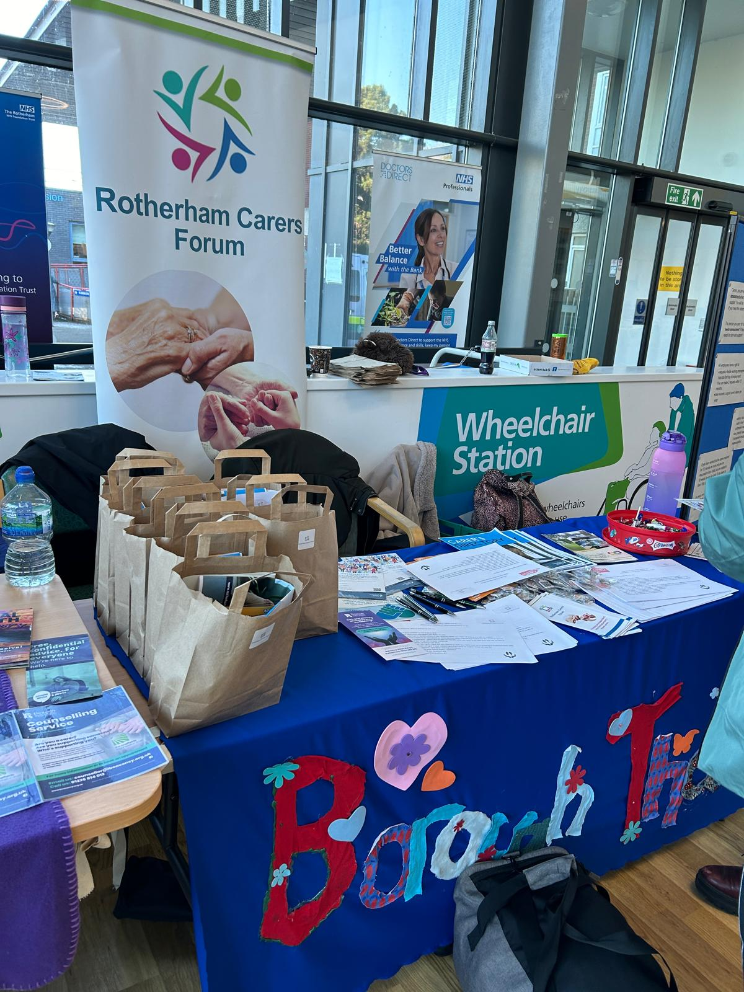
Carers Rights Day – engagement and awareness 2024

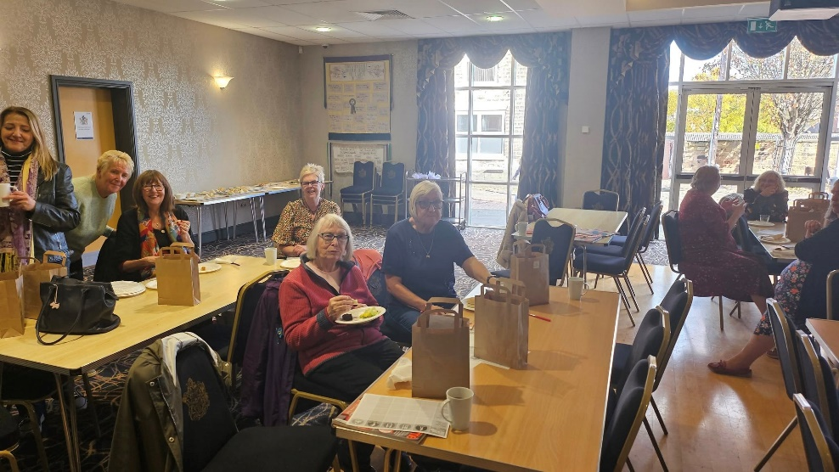
October Mental Wellbeing session 2024
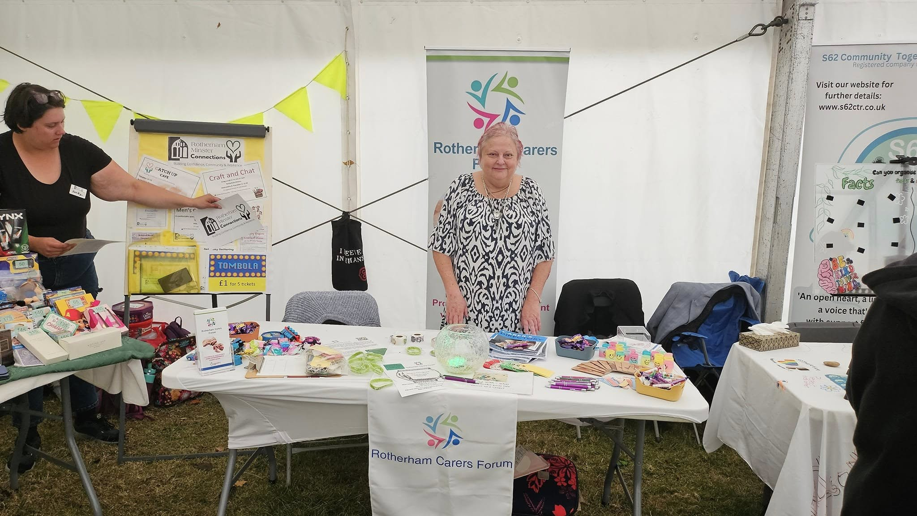
Rotherham Show 2024 – Engagement and Awareness

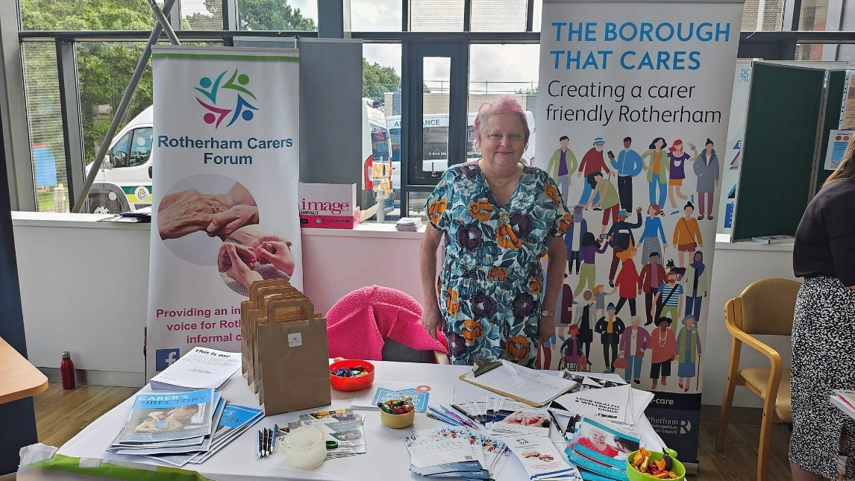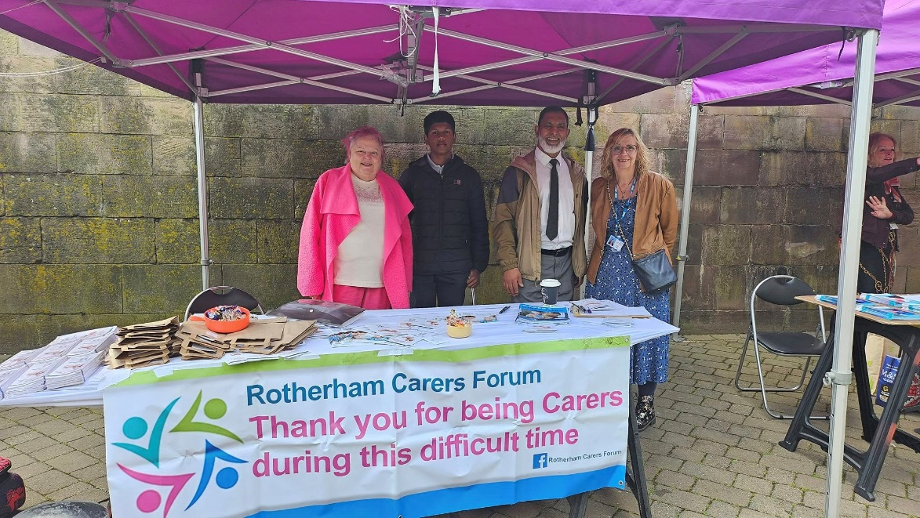
Carers Week 2024
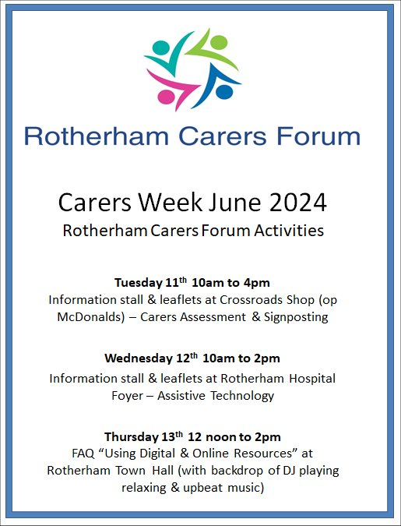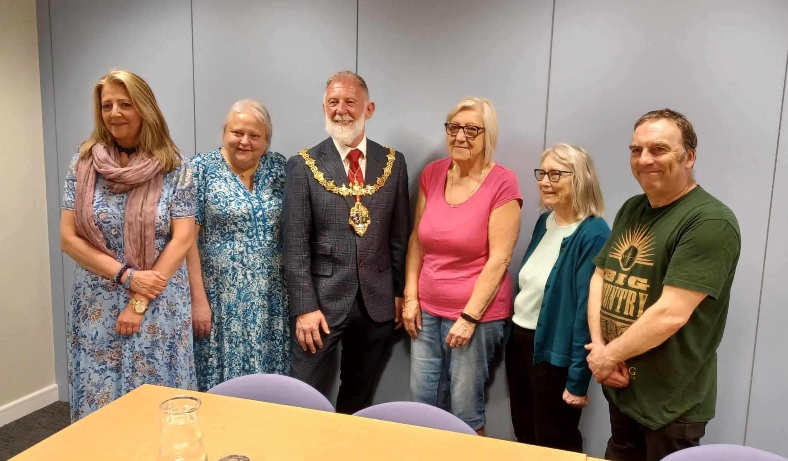
May 2024 – Monthly meet-up with Guest Speak

End

